Supplementary Table 1. Chemical structures and hydrophile-lipophile balance (HLB)
Surfactant | Chemical structure | HLB
Tween20 | 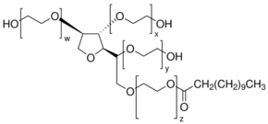 | 16.7
Tween85 | 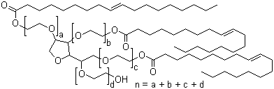 | 11
Span20 | 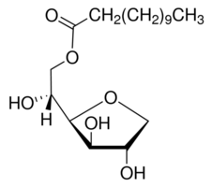 | 8.6
Span85 | 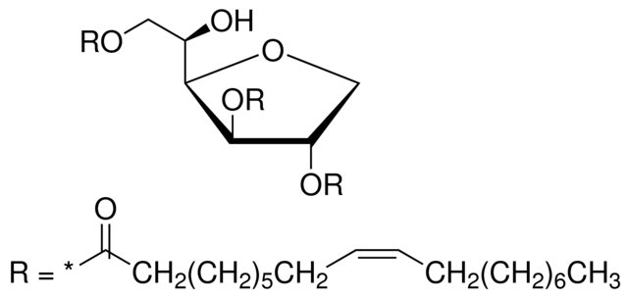 | 1.8
Supplementary Table 2. Primer list used in this study for the semi-quantitative RT-PCR
Gene | Primer sequence (5’->3’) | Product size (bp)
mecA | F: AGTTAGATTGGGATCATAGCGTCAT | 150
 | R: CGATGCCTATCTCATATGCTGTTC
fapR | F: ATTGCGCGTGGTCATGTG | 150
 | R: TACAACTCGTGCTTCTGCTCTTACC
plsX | F: ATGGCTGAAGCTGTGAAATCTG | 150
 | R:TCCATCAATCGTTGGCAATG
gyrB | F: CGACTTCAGAGAGAGGTTTGCA | 150
 | R: CTGGGATACCACGTCCGTTATC

Supplementary Fig. 1. Antibiotic susceptibility test of Δagr mutant strain with oxacillin.
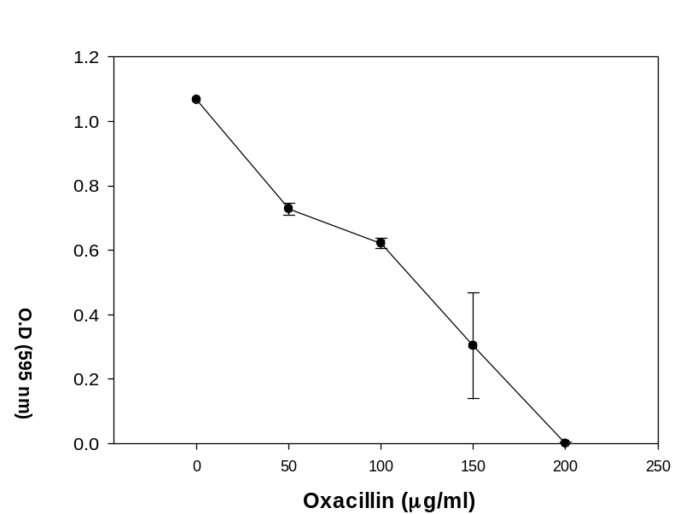

Supplementary Fig. 2. Relative phospholipid fatty acid amount of LAC and Δagr mutant strain.
